Day 6

**Day 6:**

1. Create a journey table with following fields and constraints.

* Bus_ID (No null values)
* Bus_Name (No null values)
* Source_Station (No null values)
* Destination (No null values)
* Email (must not contain any duplicates)

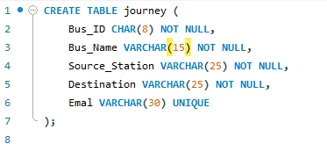

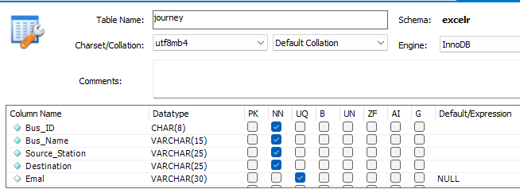

1. Create vendor table with following fields and constraints.

* Vendor_ID (Should not contain any duplicates and should not be null)
* Name (No null values)
* Email (must not contain any duplicates)
* Country (If no data is available then it should be shown as “N/A”)

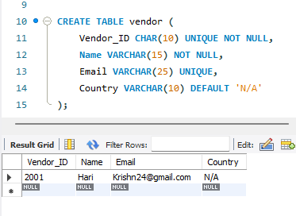

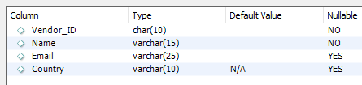

1. Create movies table with following fields and constraints.

* Movie_ID (Should not contain any duplicates and should not be null)
* Name (No null values)
* Release_Year (If no data is available then it should be shown as “-”)
* Cast (No null values)
* Gender (Either Male/Female)
* No_of_shows (Must be a positive number)

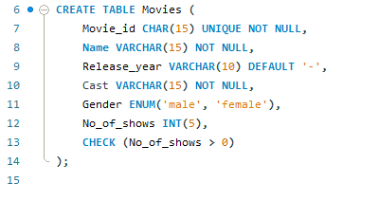

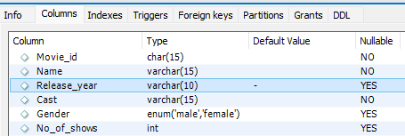

1. Create the following tables. Use auto increment wherever applicable

a. Product

* product_id - primary key
* product_name - cannot be null and only unique values are allowed
* description
* supplier_id - foreign key of supplier table

b. Suppliers

* + supplier_id - primary key
  + supplier_name
  + location

c. Stock

* + id - primary key
  + product_id - foreign key of product table
  + balance_stock

